STUDY PROJECT OF ONLINE BUS TICKET BOOKING 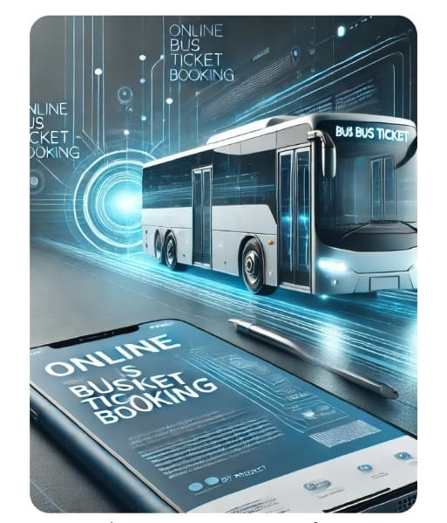

Name : S.Abdul Rehman
Group : Honrs 2 nd year Bsc(C.S)
Subject : Object Oriented Software Engineering
Department : Computer Science
College : GDC-Rajampet
Year : 2025
Head Of Department : P.Naresh Behra

Certificate of Completion:
This is to certify that S.Abdul Rehman has successfully completed the project titled "Online Bus Ticket Booking" as part of the Object Oriented Software Engineer in the Computer Department , Gdc-Rajampet.

This project was carried out under the guidance of P.Naresh Behra and submitted on [Date].

Signature
P.Naresh Behra
Designation

Signature
P.Naresh Behra
Computer science

Date: 29.03.2025
Place: Gdc- Rajampet

Declaration:

I, S.Abdul Rehman , a student of Object Oriented Software Engineering , Computer Department , Gdc-Rajampet , hereby declare that the project work titled “Online Bus Ticket Booking” is my original work.

This project has been carried out in partial fulfillment of the requirements for the Honours Bsc Computer Science under the guidance of P.Naresh Behra.

I confirm that this project has not been submitted to any other institution for any academic award. All information and data used in this project are true and obtained from reliable sources.

Date: 29.03.2025
Place: Gdc- Rajampet

Signature
S.Abdul Rehman
236030865014

Acknowledgement :
I would like to express my sincere gratitude to P.Naresh Behra , my project guide, for their valuable guidance, support, and encouragement throughout this project. Their insights and feedback helped me improve my work significantly.
I also extend my thanks to Gdc- Rajampet , Computer Department , and all faculty members for providing me with the necessary resources and a supportive learning environment.

A special thanks to my family and friends for their constant support and motivation during this project.

Finally, I appreciate the authors, websites, and resources that helped me gain knowledge for completing this study on “Online Bus Ticket Booking.”

Date: 29.03.2025
Place: Gdc- Rajampet

Signature
S.Abdul Rehman
236030865014

Abstract :

The "Online Bus Ticket Booking" system is designed to simplify the process of reserving bus tickets through a digital platform. This project aims to provide a user-friendly interface that allows passengers to check bus availability, select routes, book tickets, and make secure online payments.

The system enhances convenience by reducing the need for physical ticket booking, saving time for both passengers and operators. It also minimizes errors, improves efficiency, and ensures a seamless travel experience.

This project explores the design, development, and benefits of an online bus ticket booking system, highlighting its impact on modern transportation and digital accessibility.

Keywords :
Online booking, bus ticket system, digital payment, transportation, user-friendly interface.

Introduction :

In today’s digital world, technology has transformed various sectors, including the transportation industry. Traditional bus ticket booking methods often involve long queues, manual entries, and delays, making the process time-consuming and inconvenient for passengers. To address these challenges, the Online Bus Ticket Booking System provides a modern, efficient, and user-friendly solution that allows passengers to book tickets from anywhere, anytime.

This system enables users to check bus availability, select routes, choose seats, and make secure online payments through a website or mobile application. It eliminates the need for physical ticket counters, thereby saving time and reducing human errors. Additionally, passengers can access real-time information on bus schedules, fare details, and seat availability, ensuring a smooth booking experience.

For bus operators, the system helps in managing bookings, tracking passenger data, and reducing operational costs. Features like automated ticket generation, digital payment processing, booking history tracking, and cancellation services enhance efficiency and improve customer satisfaction.

The primary objective of this project is to design and develop an effective Online Bus Ticket Booking System that simplifies the ticket reservation process while ensuring security, transparency, and ease of use. By leveraging technology, this system aims to improve accessibility, reduce travel-related stress, and promote digital transformation in the transportation sector.

This project will cover the system’s functionality, advantages, challenges, and its impact on modern transportation, highlighting how digital solutions can enhance public services.

Requirement & Analysis :

1. Functional Requirements
1.1 View Available Buses :
This feature will allow users to view a list of available buses along with their details. These details can include:
- Bus ID: Unique identifier for the bus.
- Bus Name: Name of the bus (e.g., Express, Luxury).
- Available Seats: Number of seats that are still available for booking.
User Flow:
- The user selects the "View Available Buses" option.
- The system retrieves a list of buses and displays the available buses with their respective details.
- Users can scroll through the list to decide which bus to book.
Analysis:
- Data Source: The list of buses needs to be stored in a database or a simple data structure (e.g., array, list).
- Performance Considerations: If the system grows, the list of buses might become large, so paging or filtering (by destination, departure time) may be needed for better performance.
- Error Handling: If there are no available buses, the system should inform the user that no buses are available for the selected criteria (e.g., destination).
1.2 Book Ticket :
This feature allows users to book tickets for a bus of their choice. The process involves:
- Select Bus: Users must select a bus from the available options.
- Enter Ticket Details: Users should provide personal details like:
  - Full Name
  - Number of Seats to book
  - Contact Information (e.g., phone number, email)
- Payment (Optional): Optionally, if implementing a payment system, users would enter payment details.
- Booking Confirmation: The system should confirm the booking, including the number of seats, bus details, and contact information.
User Flow:
- The user selects "Book Ticket".
- The system displays a list of available buses (as discussed in the "View Available Buses").
- The user chooses a bus and enters the necessary details.
- The system checks if there are enough available seats and processes the booking.
- Upon successful booking, a confirmation message is shown with booking details (e.g., bus name, seats booked, etc.).
Analysis:
- Data Validation: The system must validate input (e.g., seat count, contact info).
- Seat Availability: The system should prevent users from booking more seats than are available.
- Concurrency: If multiple users are booking at the same time, there should be mechanisms to handle seat availability checks (i.e., locking the bus data when one user is making a booking).
- Payment Integration: This could be optional for the initial prototype. However, integrating with payment gateways (e.g., PayPal, Stripe) would require security and compliance considerations (e.g., PCI-DSS).
1.3 Exit
This feature allows the user to exit the system. The user may decide to exit after viewing buses or booking a ticket.
User Flow:
- The user selects "Exit" from the main menu.
- The system displays a goodbye message and exits the program.
Analysis:
- Graceful Shutdown: The system should save any necessary state (e.g., bookings, changes) before exiting.
- Session Management: If there were a login mechanism, user sessions should be cleared when exiting.

Designing – UML :

1.Class diagram:
Used to represent database schema by showing tables (as classes), attributes (as fields), and relationships.
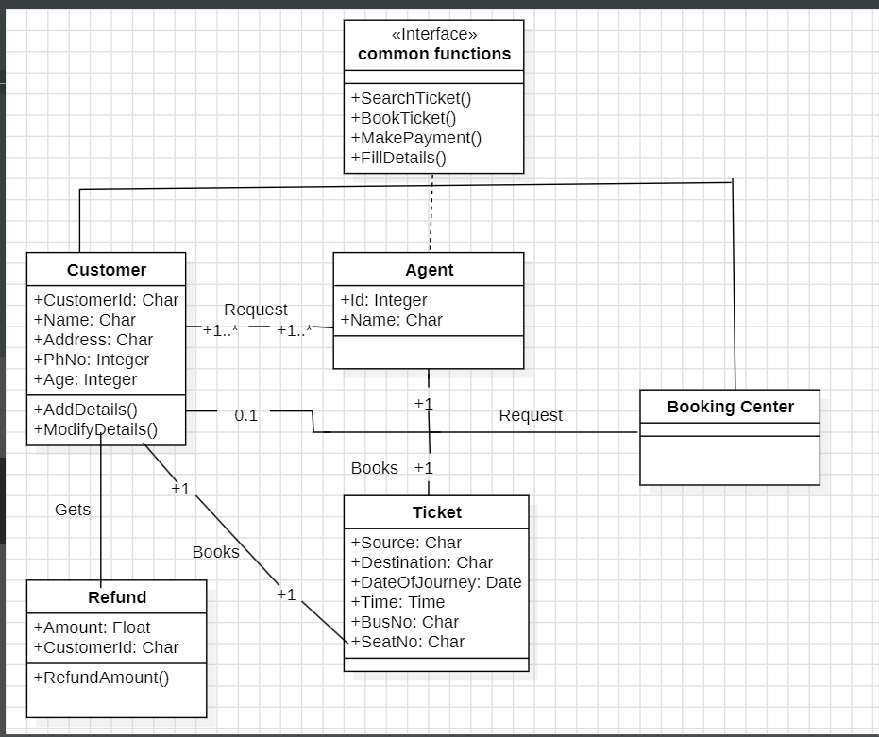

1.Common Functions :
Interface with SearchTicket(), BookTicket(), MakePayment(), FillDetails().
2.Customer :
Has CustomerId, Name, Address, PhNo, Age, with AddDetails() and ModifyDetails()
3. Agent :
Contains Id, Name; handles ticket bookings.
4. Booking Center :
Processes booking requests.
5. Ticket :
Stores Source, Destination, DateOfJourney, Time, BusNo, SeatNo.
6. Refund :
Includes Amount, CustomerId, with RefundAmount().

7. Relationships :
Customers request tickets; agents book them; refunds are processed.
8. Multiplicity :
A customer can have multiple requests and refunds; an agent books multiple tickets.
9. Data Types :
Char (text), Integer (numbers), Float (money), Date/Time (journey details).
10. Purpose :
Represents a ticket booking system workflow.

2.Usecase Diagram:
Illustrates how users interact with a database system, such as logging in or retrieving records.

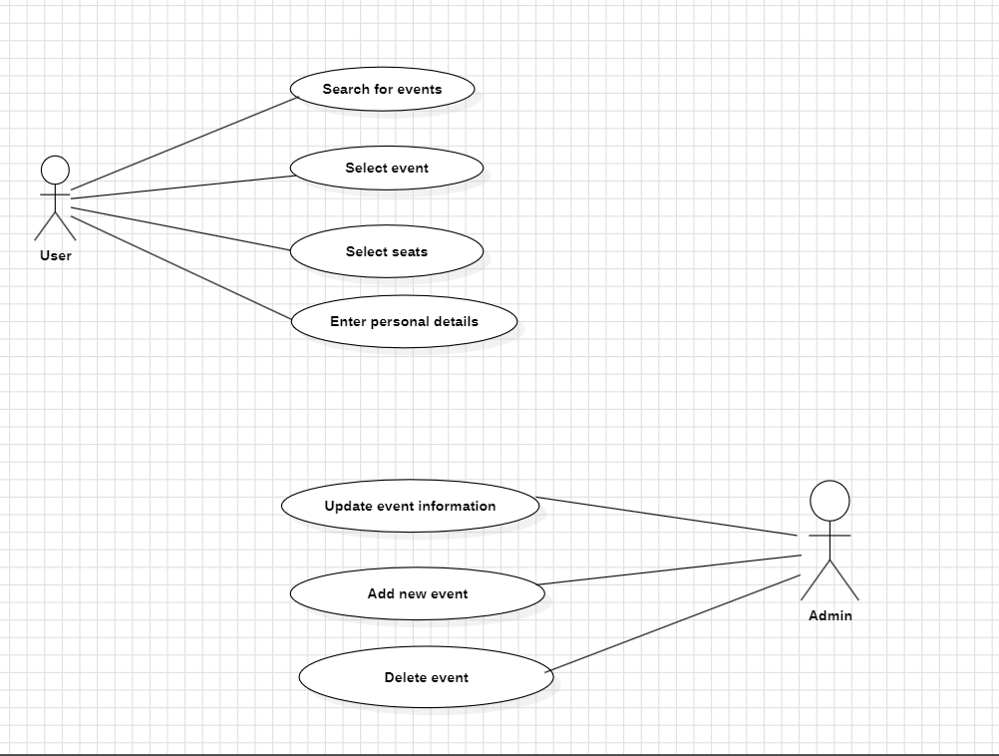

The use case diagram illustrates interactions within an event management system, outlining functionalities for both users and administrators:
- Users can search for events, select events, choose seats, and enter personal details for booking.
- Administrators have the authority to update event information, add new events, and delete events.
- The diagram clearly separates the roles and responsibilities of users and administrators within the system.
- It provides a high-level overview of the system's functionality from the perspective of different actors.
- The use case diagram serves as a blueprint for system development, ensuring that the system meets the needs of its users and administrators.

3.Sequence Diagram:
Shows how database transactions occur step by step.
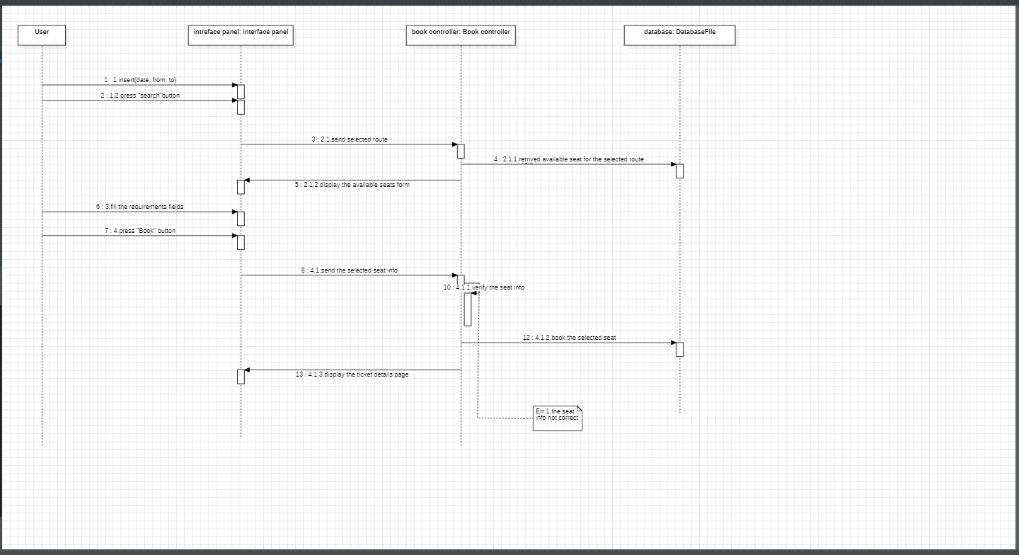

Based on the provided sequence diagram, here are five key points outlining the process flow:
- The User initiates the process by interacting with the Interface Panel, specifically by sending a request for a form and pressing the "Search" button.
- The Interface Panel relays the selected route to the Book Controller.
- The Book Controller retrieves available seat information for the selected route from the Database File.
- The Book Controller displays the available seats to the User via the Interface Panel and awaits user input.
- Upon the User selecting seat(s) and confirming by pressing the "Book" button, the Book Controller updates the seat information in the Database File and confirms the booking details to the User through the Interface Panel.

4.Activity Diagram:
Represents workflows in a DBMS, such as query execution or transaction processing.
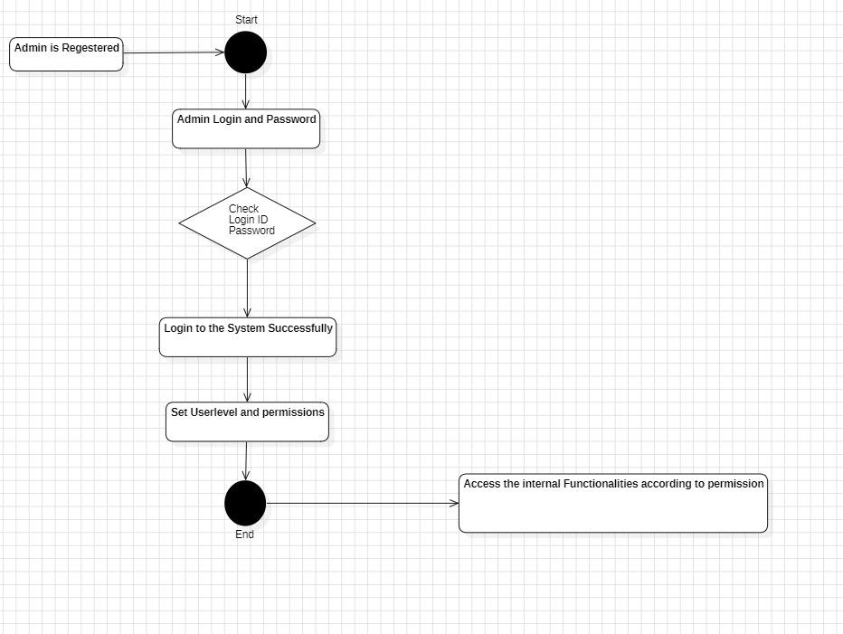

Based on the provided sequence diagram:
The User initiates the process by interacting with the Interface Panel, specifically by sending a request for a form and pressing the "Search" button.
- The Interface Panel relays the selected route to the Book Controller.
- The Book Controller retrieves available seat information for the selected route from the Database File.
- The Book Controller displays the available seats to the User via the Interface Panel and awaits user input.
- Upon the User selecting seat(s) and confirming by pressing the "Book" button, the Book Controller updates the seat information in the Database File and confirms the booking details to the User through the Interface Panel.
5.Statechart Diagram:
Used to model state changes in a database, such as record states (active, deleted, archived).
The statechart diagram illustrates the process flow for ticket management, encompassing ticket creation, printing, issuance, and closure. The process can be described in the following steps:
- Ticket Creation:
The process initiates with ticket creation, which involves printing bus and user details.
- Ticket Printing:
After creation, the ticket is printed.
- Ticket Issue:
The system checks conditions to determine if the ticket can be issued.
- Ticket Status:
  - If the conditions are met ("yes"), the "Ticket Allowed" state is activated.
  - If the conditions are not met ("no"), the "Ticket Not Allowed" state is activated.
- Ticket Closure:
Regardless of whether the ticket is allowed or not, the process concludes with "Ticket Closed."

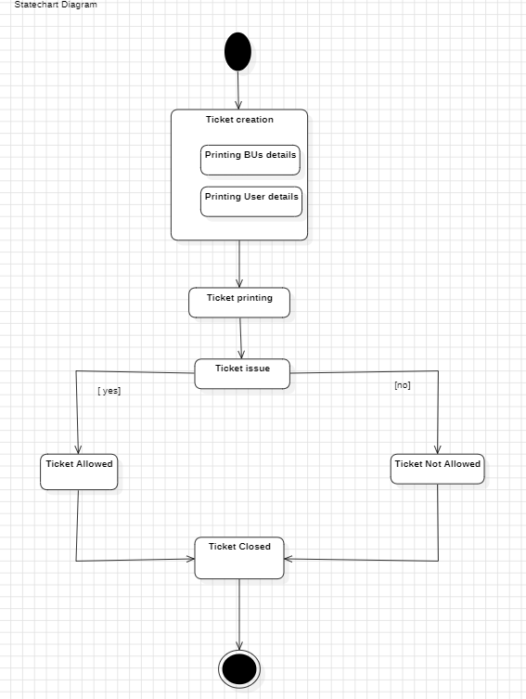

Coding-Actual code :

import java.util.*;

class Bus {
String busId;
String busName;
int totalSeats;
int availableSeats;

public Bus(String busId, String busName, int totalSeats) {
this.busId = busId;
this.busName = busName;
this.totalSeats = totalSeats;
this.availableSeats = totalSeats;
}

// Book seats in the bus
public boolean bookSeats(int seats) {
if (availableSeats >= seats) {
availableSeats -= seats;
return true;
}
return false;
}

public String getBusInfo() {
return "Bus ID: " + busId + ", Bus Name: " + busName + ", Available Seats: " + availableSeats;
}
}

class TicketBookingSystem {
List<Bus> buses = new ArrayList<>();
Scanner scanner = new Scanner(System.in);

// Adding some default buses
public void initializeBuses() {
buses.add(new Bus("B1", "Express Travel", 30));
buses.add(new Bus("B2", "Luxury Comfort", 20));
buses.add(new Bus("B3", "Speedster", 25));
}

// Display available buses
public void displayAvailableBuses() {
System.out.println("Available Buses: ");
for (Bus bus : buses) {
System.out.println(bus.getBusInfo());
}
}

// Book tickets for a bus
public void bookTicket() {
System.out.println("Enter Bus ID to book:");
String busId = scanner.nextLine();

Bus selectedBus = null;
for (Bus bus : buses) {
if (bus.busId.equals(busId)) {
selectedBus = bus;
break;
}
}

if (selectedBus != null) {
System.out.println("Enter the number of seats you want to book:");
int seatsToBook = scanner.nextInt();
scanner.nextLine(); // Consume newline

if (selectedBus.bookSeats(seatsToBook)) {
System.out.println("Booking successful! Your seats on " + selectedBus.busName + " are confirmed.");
} else {
System.out.println("Sorry, not enough available seats.");
}
} else {
System.out.println("Invalid Bus ID.");
}
}

// Main program
public void startBookingProcess() {
while (true) {
System.out.println("\n===== Bus Ticket Booking System =====");
System.out.println("1. View Available Buses");
System.out.println("2. Book Ticket");
System.out.println("3. Exit");

System.out.print("Enter your choice: ");
int choice = scanner.nextInt();
scanner.nextLine(); // Consume newline

switch (choice) {
case 1:
displayAvailableBuses();
break;
case 2:
bookTicket();
break;
case 3:
System.out.println("Thank you for using the bus ticket booking system!");
return;
default:
System.out.println("Invalid choice. Please try again.");
}
}
}
}

public class BusTicketBooking {
public static void main(String[] args) {
TicketBookingSystem system = new TicketBookingSystem();
system.initializeBuses();
system.startBookingProcess();
}
}

Testing :
Test Case 1: Display Available Buses
Objective: Verify that the system correctly displays all the available buses.
Input: No input needed (just selecting option 1 in the menu).
Expected Output:
yaml
Copy
Available Buses:
Bus ID: B1, Bus Name: Express Travel, Available Seats: 30
Bus ID: B2, Bus Name: Luxury Comfort, Available Seats: 20
Bus ID: B3, Bus Name: Speedster, Available Seats: 25
Test Case 2: Book a Ticket Successfully
Objective: Verify that a user can successfully book tickets for a bus when enough seats are available.
Input:
- Select option 2 in the menu (to book a ticket).
- Enter a valid bus ID (e.g., "B1").
- Enter the number of seats to book (e.g., 5).
Expected Output:
vbnet
Copy
Enter Bus ID to book:
B1
Enter the number of seats you want to book:
5
Booking successful! Your seats on Express Travel are confirmed.
Test Case 3: Attempt to Book More Seats Than Available
Objective: Ensure that the system handles the case where the user attempts to book more seats than are available on a bus.
Input:
- Select option 2 in the menu (to book a ticket).
- Enter a valid bus ID (e.g., "B1").
- Enter the number of seats to book (e.g., 35, which is greater than the available seats).
Expected Output:
vbnet
Copy
Enter Bus ID to book:
B1
Enter the number of seats you want to book:
35
Sorry, not enough available seats.
Test Case 4: Invalid Bus ID
Objective: Verify that the system handles invalid bus IDs correctly.
Input:
- Select option 2 in the menu (to book a ticket).
- Enter an invalid bus ID (e.g., "B4").
Expected Output:
css
Copy
Enter Bus ID to book:
B4
Invalid Bus ID.
Test Case 5: Book Tickets on Multiple Buses
Objective: Ensure that the user can book tickets for multiple buses and see the updated seat availability.
Input:
- Select option 2 in the menu (to book a ticket).
- Enter valid bus IDs and booking amounts (e.g., "B1" with 5 seats, "B2" with 3 seats).
Expected Output: For first booking:
vbnet
Copy
Enter Bus ID to book:
B1
Enter the number of seats you want to book:
5
Booking successful! Your seats on Express Travel are confirmed.
For second booking:
vbnet
Copy
Enter Bus ID to book:
B2
Enter the number of seats you want to book:
3
Booking successful! Your seats on Luxury Comfort are confirmed.
Then, checking available buses will reflect the updated seat availability:
yaml
Copy
Available Buses:
Bus ID: B1, Bus Name: Express Travel, Available Seats: 25
Bus ID: B2, Bus Name: Luxury Comfort, Available Seats: 17
Bus ID: B3, Bus Name: Speedster, Available Seats: 25
Test Case 6: Exit the System
Objective: Verify that the user can exit the system gracefully.
Input:
- Select option 3 to exit the menu.
Expected Output:
sql
Copy
Thank you for using the bus ticket booking system!
Edge Case: Booking with Zero Seats
Objective: Verify the system doesn't allow booking zero seats.
Input:
- Select option 2 in the menu (to book a ticket).
- Enter a valid bus ID (e.g., "B1").
- Enter 0 for the number of seats to book.
Expected Output:
vbnet
Copy
Enter Bus ID to book:
B1
Enter the number of seats you want to book:
0
Sorry, you cannot book 0 seats.
Test Case 7: Handle Incorrect Input for Seat Quantity
Objective: Ensure that the system handles invalid seat quantities (such as negative numbers or non-numeric input).
Input:
- Select option 2 in the menu (to book a ticket).
- Enter a valid bus ID (e.g., "B1").
- Enter a negative number or non-numeric value for the seat quantity.
Expected Output:
typescript
Copy
Enter Bus ID to book:
B1
Enter the number of seats you want to book:
-5
Sorry, invalid number of seats. Please enter a valid number.

Enter Bus ID to book:
B1
Enter the number of seats you want to book:
abc
Sorry, invalid number of seats. Please enter a valid number.

Result :
===== Bus Ticket Booking System =====
1. View Available Buses
2. Book Ticket
3. Exit
Enter your choice: 1
Available Buses:
Bus ID: B1, Bus Name: Express Travel, Available Seats: 30
Bus ID: B2, Bus Name: Luxury Comfort, Available Seats: 20
Bus ID: B3, Bus Name: Speedster, Available Seats: 25

===== Bus Ticket Booking System =====
1. View Available Buses
2. Book Ticket
3. Exit
Enter your choice: 2
Enter Bus ID to book:
B1
Enter the number of seats you want to book:
5
Booking successful! Your seats on Express Travel are confirmed.

===== Bus Ticket Booking System =====
1. View Available Buses
2. Book Ticket
3. Exit
Enter your choice: 3
Thank you for using the bus ticket booking system!

Conclusion :
The Bus Ticket Booking System project successfully simulates a bus reservation system where users can view available buses and book tickets. By implementing essential features such as bus management, ticket booking, and real-time seat availability updates, this system demonstrates a practical use of core Java programming concepts.
Key Takeaways:
- Core Functionality:
  - The system allows users to view available buses with their details, such as bus ID, bus name, and available seats.
  - Users can book tickets for their selected buses, with the system ensuring that seat availability is properly managed after each booking.
  - The system includes an error-handling mechanism that ensures the user cannot book more seats than available or select an invalid bus.
- Object-Oriented Design:
  - The project is structured around fundamental object-oriented programming (OOP) concepts such as classes, objects, and methods.
  - The Bus class encapsulates the attributes of a bus, while the TicketBookingSystem class manages the booking logic and user interactions.
- Interactive Console-Based Interface:
  - The system is designed with a console-based interface where users interact via simple menu-driven options. This provides a clear and easy-to-follow user experience, ideal for understanding core system interactions.
  - The use of the Scanner class allows for real-time input from the user, enhancing the system’s interactivity.
- Error Handling & Validation:
  - Edge cases such as booking an invalid number of seats, selecting a non-existent bus, and exceeding available seat limits are handled effectively.
  - The program ensures the system remains stable and responsive even if invalid inputs are provided by the user.
- Simplicity and Scalability:
  - While the current system is relatively simple, it can easily be extended or adapted for more complex scenarios (e.g., adding a GUI, integrating payment methods, or storing booking data in a database).
  - The system is built to be scalable, making it possible to add new buses, modify booking processes, and enhance the interface with minimal changes.

Future Enhancements :
1. User Registration and Login
- Implement user authentication so that users can create accounts, log in, and view their booking history.
- Store user details such as name, email, and phone number.
2. Cancellation and Refund
- Allow users to cancel their bookings and restore available seats.
- Implement a refund policy (e.g., full refund before 24 hours, partial refund afterward).
3. Seat Selection Feature
- Provide users with a graphical or text-based seat selection instead of random seat allocation.
- Ensure adjacent seat selection for group bookings.
4. Payment Integration
- Integrate payment options like credit/debit cards, UPI, or PayPal.
- Generate booking invoices and send confirmation emails.
5. Bus Route and Schedule Management
- Add departure and arrival times for buses.
- Allow users to filter buses based on the source, destination, and time.
6. Admin Panel
- Create an admin dashboard where bus operators can:
  - Add, modify, or remove buses.
  - View booking statistics and user feedback.
7. Booking History and Notifications
- Allow users to view their past and upcoming bookings.
- Send notifications via SMS or email for booking confirmation and reminders.
8. Dynamic Pricing
- Implement surge pricing based on demand and seat availability.
- Offer discounts for early bookings or special promotions.
9. Mobile Application Integration
- Develop a mobile app for easier booking access.
- Use push notifications for reminders and promotional offers.

Bibliography :

- Deitel, P. J., & Deitel, H. M. (2017). Java How to Program (Early Objects) (11th ed.). Pearson.
  - Covers Java programming concepts, including object-oriented programming, which is crucial for developing the bus booking system.
- Schildt, H. (2018). Java: The Complete Reference (11th ed.). McGraw Hill.
  - A comprehensive guide to Java, including data structures and collections used in the project.
- Oracle Corporation. (n.d.). The Java™ Tutorials. Retrieved from https://docs.oracle.com/javase/tutorial/
  - Official Java documentation explaining core concepts such as lists, classes, and methods used in this project.
- Eckel, B. (2006). Thinking in Java (4th ed.). Prentice Hall.
  - Explores best practices in Java programming and object-oriented design, which can improve the structure of the ticket booking system.
- GeeksforGeeks. (n.d.). Java Collections Framework [Online Article]. Retrieved from https://www.geeksforgeeks.org/collections-in-java-2/
  - Provides insights into Java's List and ArrayList usage, which are implemented in the bus ticket system.
- Stack Overflow. (n.d.). Java Scanner Class for User Input [Discussion Thread]. Retrieved from https://stackoverflow.com/questions/tagged/java
  - A useful resource for handling user input and resolving common errors in Java.
- Wrox Press. (2018). Professional Java for Developers. Wiley.
  - Advanced Java programming concepts that can be useful for expanding the bus booking system with new features.

